**Project Initialization and Planning Phase**

| Date | 2 October 2024 |
| --- | --- |
| Team ID | 740031 |
| Project Name | OptiInsight - Revolutionizing Ophthalmic Care With Deep Learning For Predictive Eye Disease Analysis |
| Maximum Marks | 3 Marks |

**Define Problem Statements (Customer Problem Statement Template):**

In today’s fast-paced world, healthcare providers often face challenges in detecting eye diseases, such as diabetic retinopathy and glaucoma, at an early stage. Traditional diagnostic methods rely heavily on manual analysis of ophthalmic images, which is often time-consuming, subjective, and prone to human error. This leads to delays in diagnosis and treatment, resulting in preventable vision loss and a higher burden on patients and healthcare systems.

Reference: https://miro.com/templates/customer-problem-statement/

**Example:**

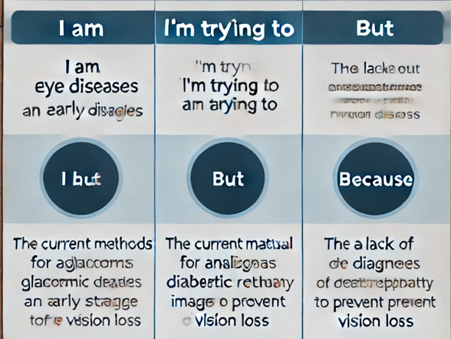

|  |  |  |  |  |  |
| --- | --- | --- | --- | --- | --- |
| **Problem**  **Statement (PS)** | **I am**  **(Customer)** | **I’m trying to** | **But** | **Because** | **Which makes me feel** |
| PS-1 | An ophthalmologist or healthcare professional | Improve the accuracy and efficiency of eye disease diagnosis | Current methods are time-consuming, subjective, and prone to human error . | This leads to delayed diagnosis, inappropriate treatment, and potentially irreversible vision loss. | Frustrated and overwhelmed by the time-consuming and error-prone nature of current diagnosis methods. . |
| PS-2 | A person at risk of eye disease or with a family history of eye problems | Detect eye diseases at early stages, before they progress and cause significant vision loss | Existing screening methods are often limited in their ability to identify early-stage conditions | Early detection is crucial for effective treatment and preventing vision loss. | Concerned about the potential for undetected eye diseases and the consequences of delayed diagnosis. |